# Evaluation of forecasting methods

## Time series analysis

Time series may exhibit trend, seasonal and irregular components. In the following we will investigate methods that apply to the given time series and extract promising components.

### Trend analysis

The original, unedited time series of energy prices in belgium in 2010 is depicted in Figure 1.

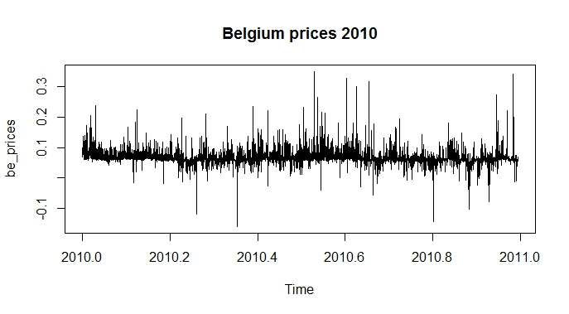

Figure 1: Belgian energy prices over 1 year

This time series shows a strong irregular component and small trends throughout the observed time range, however there is no seasonal behavior associated as energy prices are traded on a daily basis and do not exhibit any repetitive patterns over a season.

For a trend analysis we apply the Simple Moving Average (SMA) method to average out random fluctuations and reveal trends in the data.

The SMA method is configured with a moving window of a specific size to smooth out any disturbing variations in the data. Since the total number of observations exceeds 8000 (number of hours over a year) the window sizes were configured to n=10, n=100 and n=600. The results are shown below.

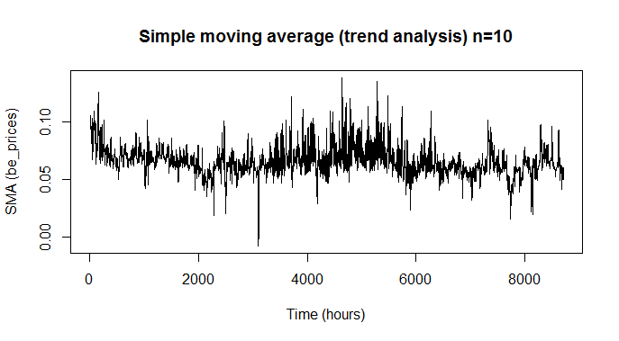

Figure 2: Simple moving average, sliding window size = 10

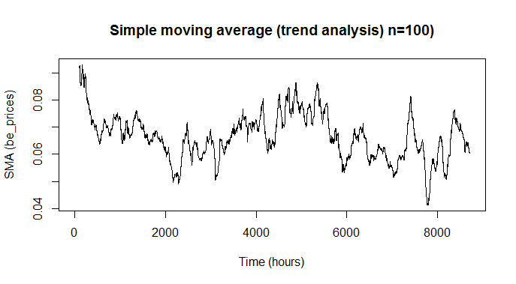

Figure 3: Simple moving average, sliding window size = 100

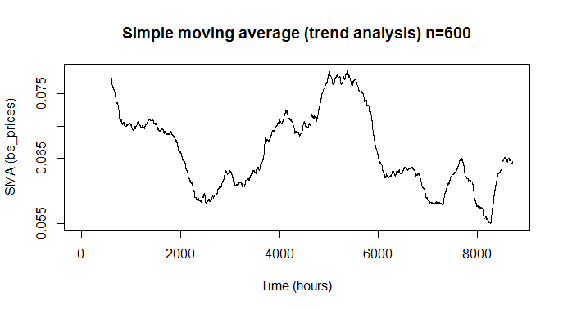

Figure 4: Simple moving average, sliding window size = 600

From the results we can deduce that the dataset exhibits a trend which may help in generating an appropriate forecasting model.

## Forecasting models

### Simple Exponential Smoothing

Time series with a constant level and roughly constant variations over time can be described by an additive model and thus can be applied to the Simple Exponential Smoothing (SES) forecasting.

Simple Exponential Smoothing is based on the HoltWinters method but without considering trend and seasonal components.

We constrain the belgium energy prizes to the first 200 observations in order to get some usable results (Figure 5) .

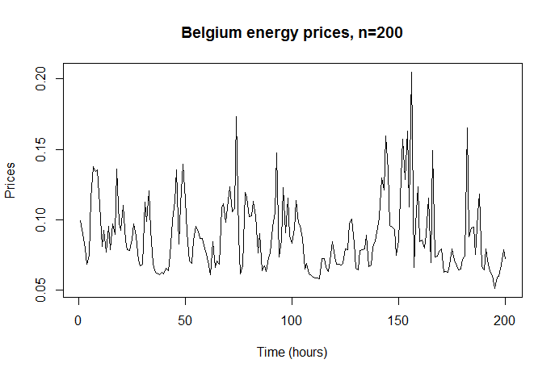

Figure 5: First 200 hours of energy prices in belgium, starting January 2010

Figure 6 depicts the results of applying an SES model to the belgian time series.

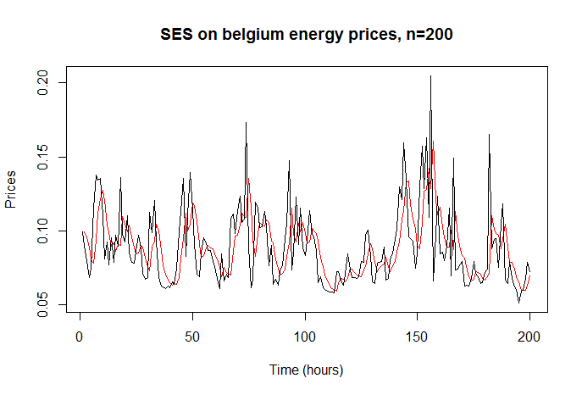

Figure 6: SES applied to belgian energy prices

In this figure the black line shows the original time series whereas the red line denotes the predicted time series based on SES. The SES series lags behind the original series by some degree and some random fluctuations are averaged out additionally.

In Figure 7 an SES forecast beyond the given data is applied to this series. The blue line shows the actual forecast of energy prices whereas the dark and light blue shaded areas denote the 80% and 95% confidence intervals, respectively.

Remarkably the forecast just consists of a straight line, having the same value as the original series’ last observation. This is due to the model being trained without considering trend and seasonality components in the series, so the dataset is actually expected to have constant mean and variation.

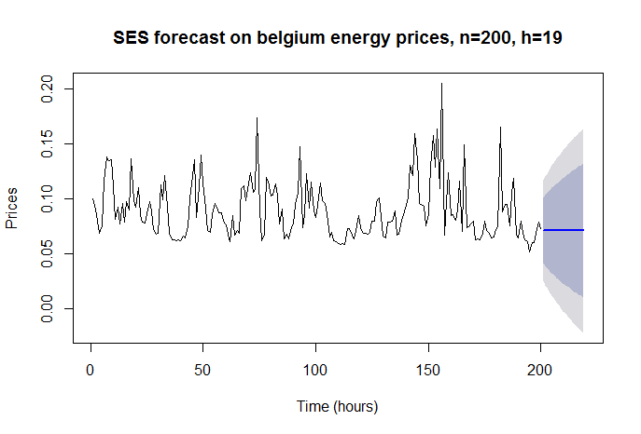

Figure 7: Forecasting 19 hours of belgian energy prices

However, since this dataset does neither have a constant mean nor constant variation, it would first have to be transformed into a series appropriate for this model. A common approach to achieve this is to differentiate the series one or more times, which has to be transformed back after the forecasting is done.

In this case, we differentiate the series one time. The results are shown in Figure 8.

From the results we can estimate that the resulting series does have a constant mean and constant variation on average. After applying the SES model to this time series the predicted values smooth out all random fluctuations and take values of the approximated mean of the series (Figure 9).

The actual forecast using SES based on the differentiated series is again a straight line, but since the series has zero mean and near constant variance this can be taken as reasonable forecast. Also, the prediction intervals stay the same with increasing forecast window size due to the series constant variance and mean. When transforming the data back to the original series the forecasted values have to be transformed as well to obtain the forecasts of the original dataset.

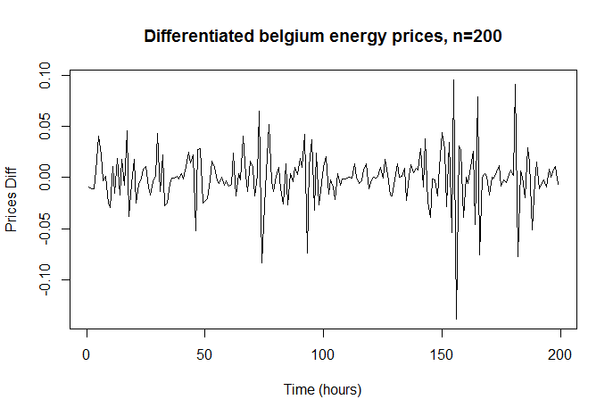

Figure 8: Belgian energy prices, one time differentiated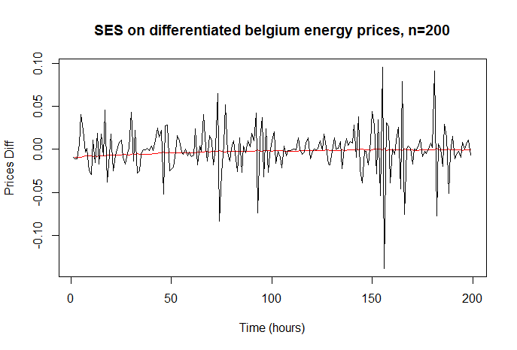

Figure 9: SES model applied to differentiated time series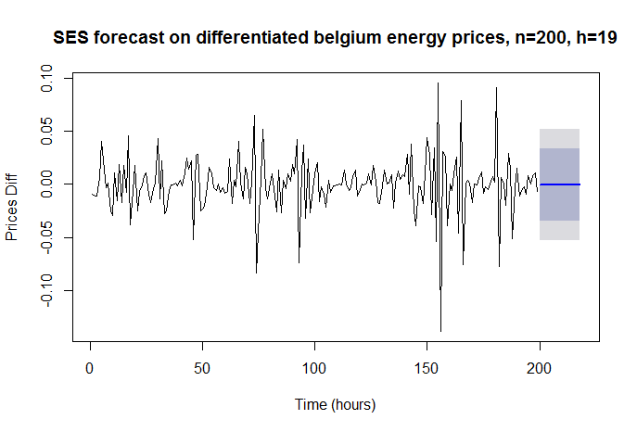

Figure 10: Forecast on differentiated time series, 19 intervals into the future

## Accuracy Measures

Forecast accuracy can be evaluated by investigating the value difference between the actual and forecasted data points. These are called residuals or forecast errors, which represent the difference between the actual and the predicted series, respectively.